**Steps for GA account Creation**

1. Click [here](http://www.google.com/analytics/) to go to Google Analytics.  
   Note: If you have a Google account, and are not signed in, click Sign in. If you do not have a Google account, click Create an account.



1. Click start for free
2. Once you have signed into your Google account, click Access Google Analytics.
3. Click Sign up.

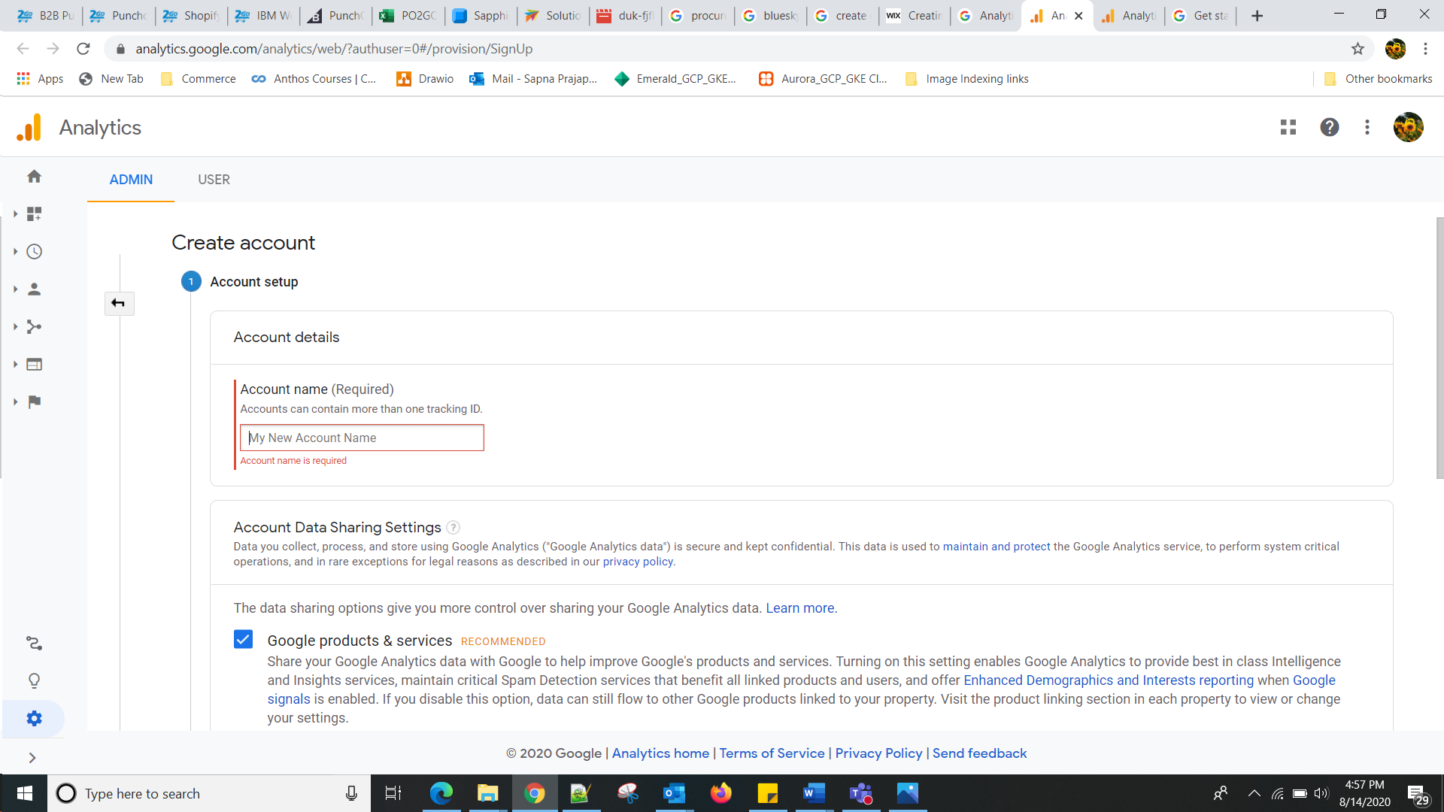

Enter Account name 🡪Scroll down select the checkboxes🡪click next

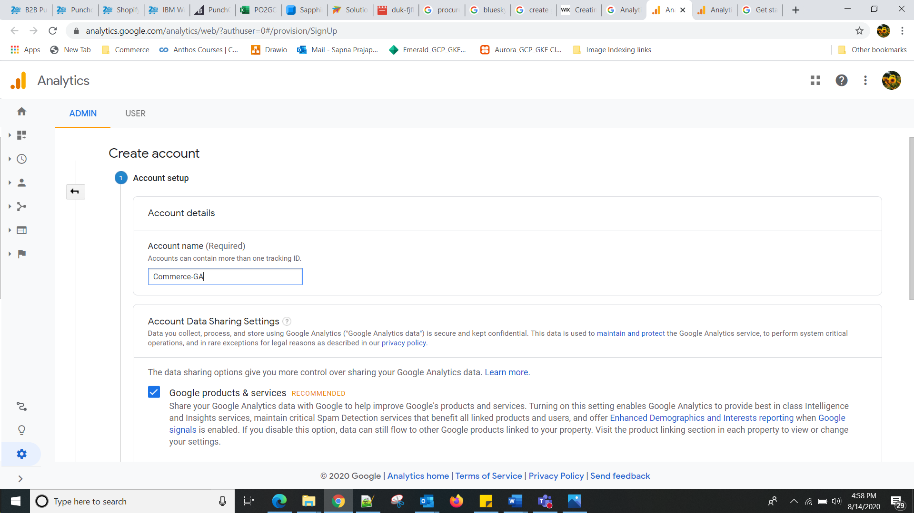

Under Data Sharing Options, check the boxes next to the options that you want.

Fill in your Account Name, Website Name, Website URL, and select an Industry Category and Reporting Time Zone.

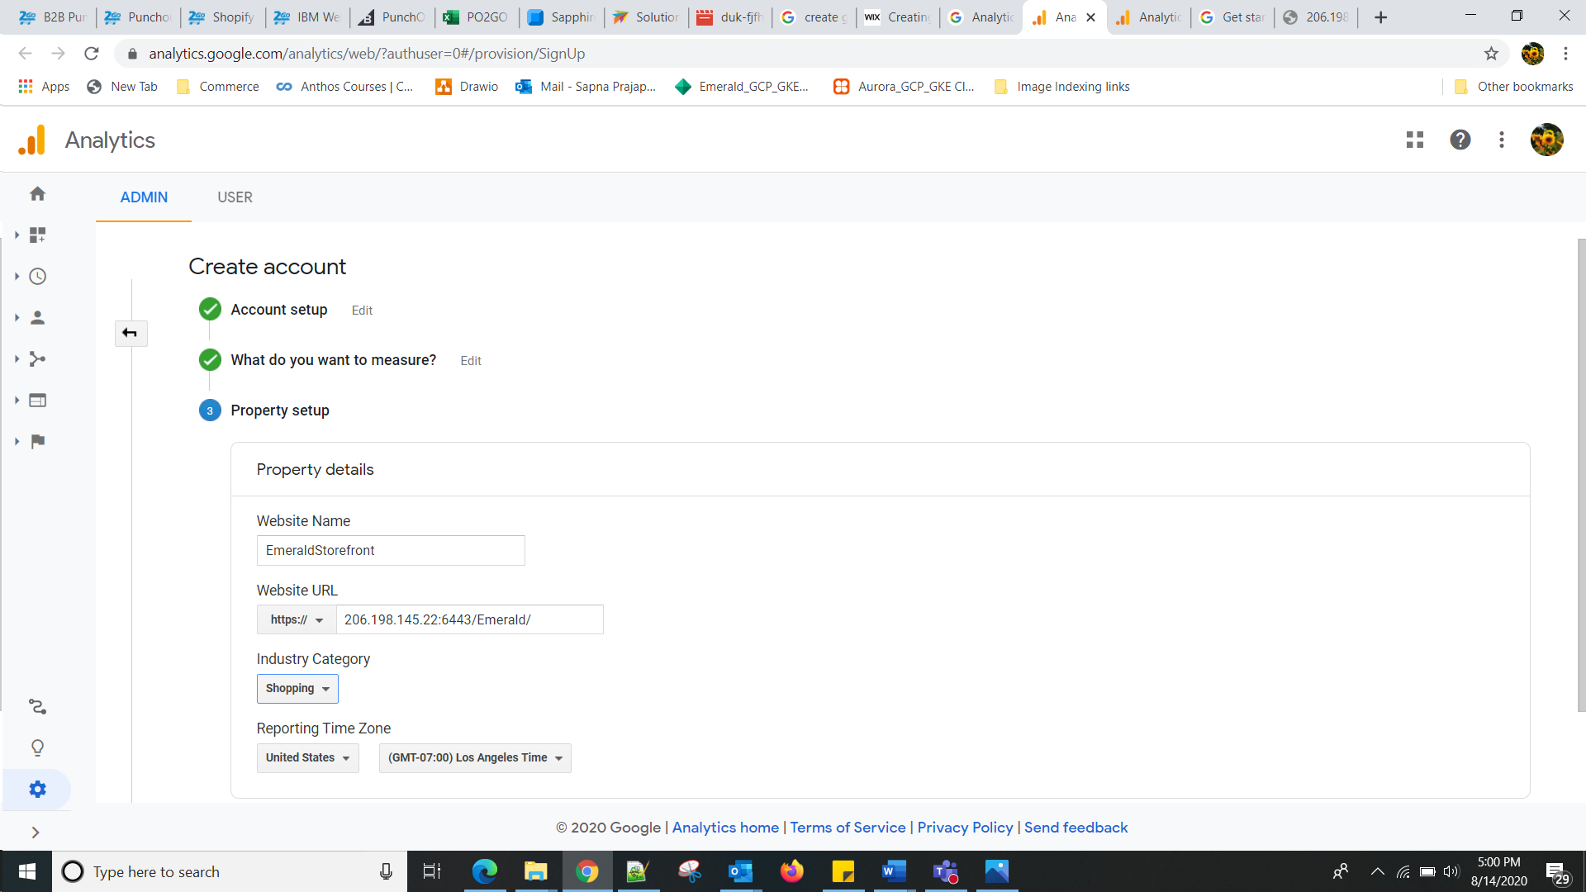

Click create

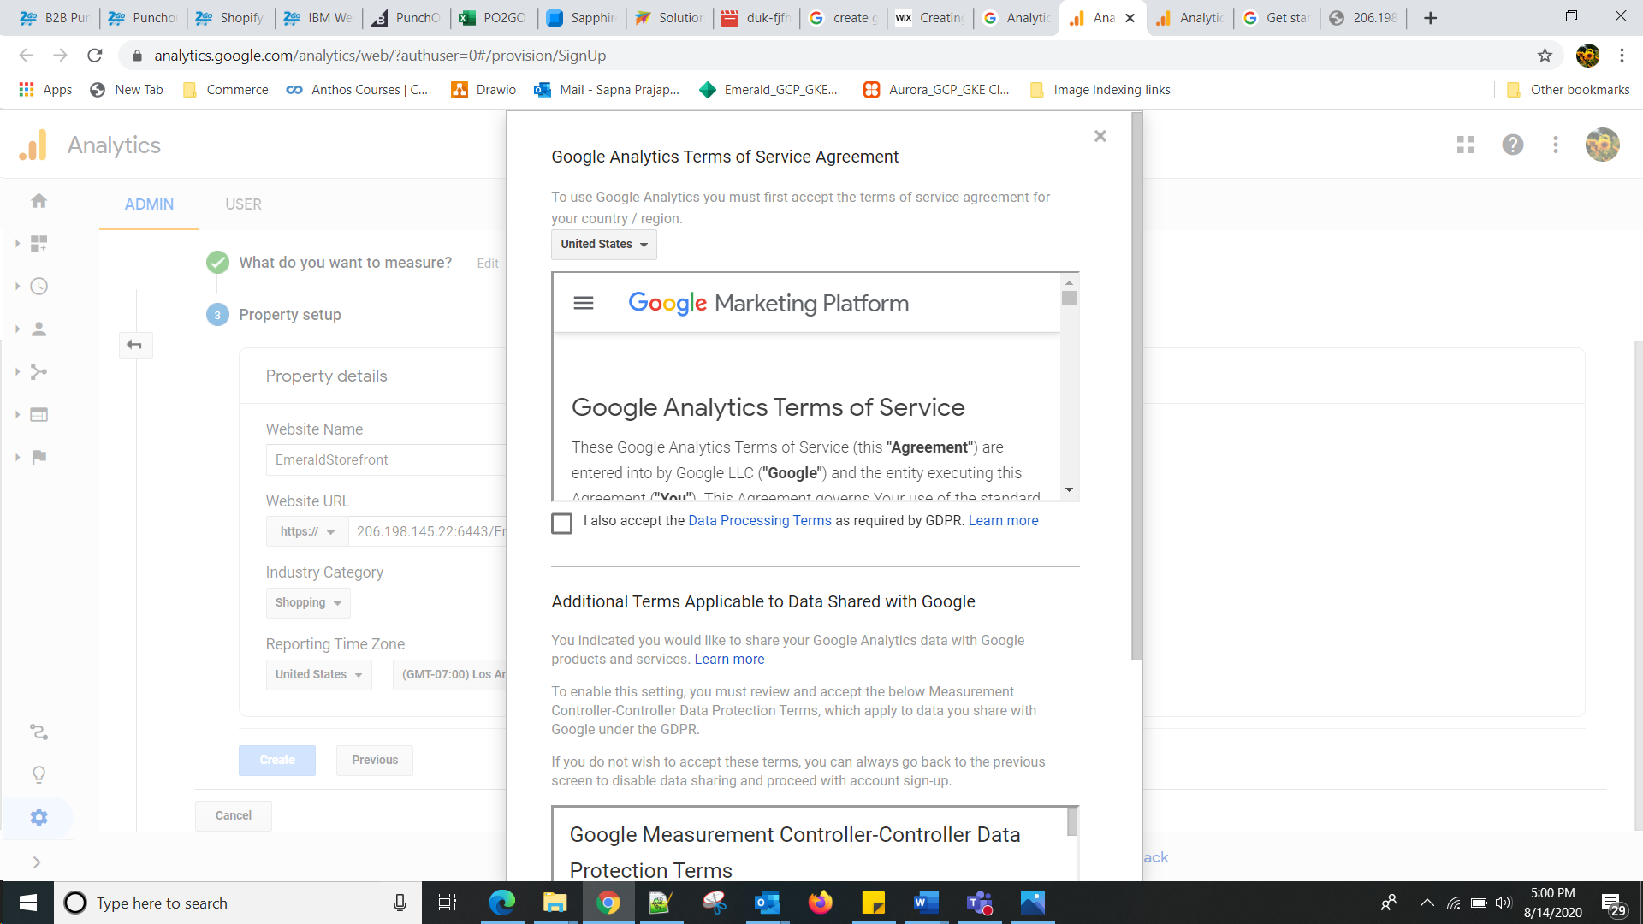

From the Google Analytics Terms of Service Agreement that opens, click I Accept

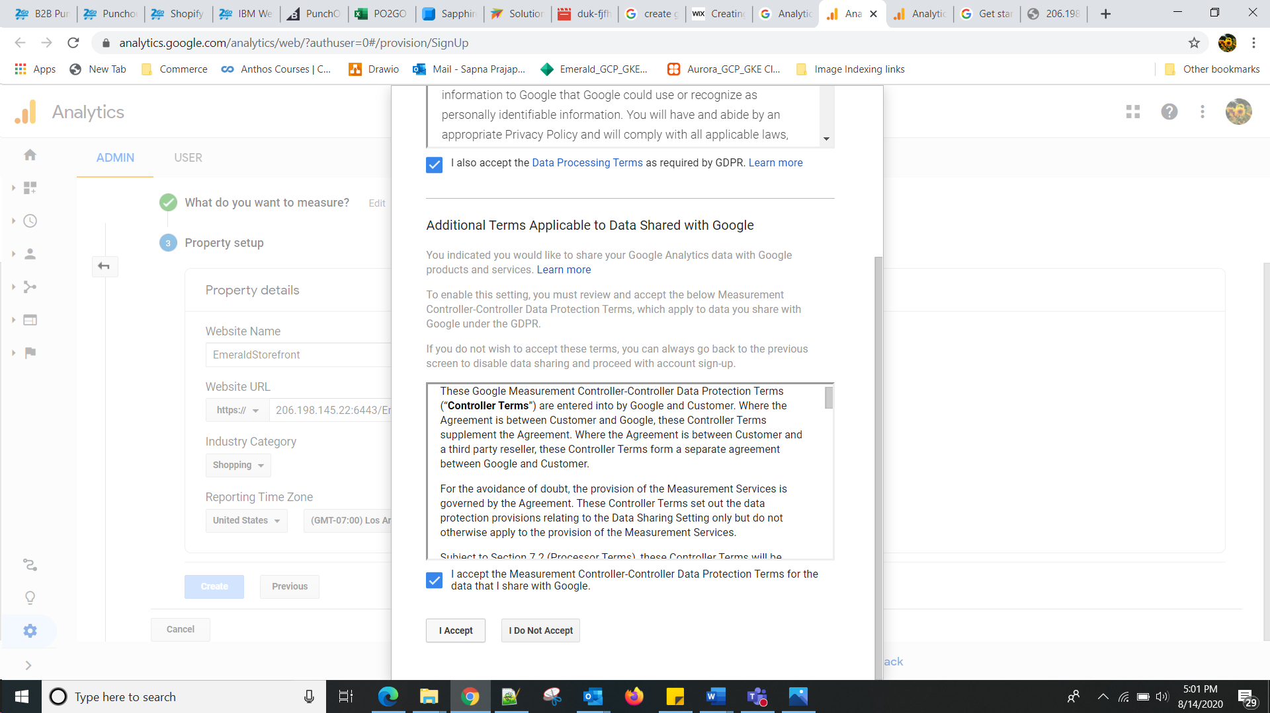

1. Click Get Tracking ID.

[Add the Tracking ID](https://support.wix.com/en/article/adding-your-google-analytics-code-to-your-wix-site-1945442) to you Wix site

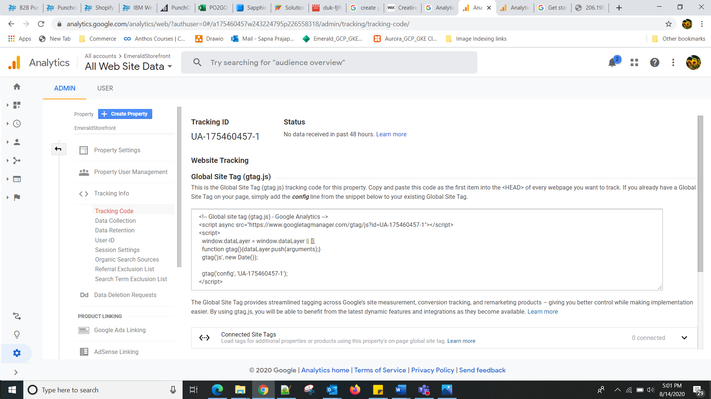

Reference docs: